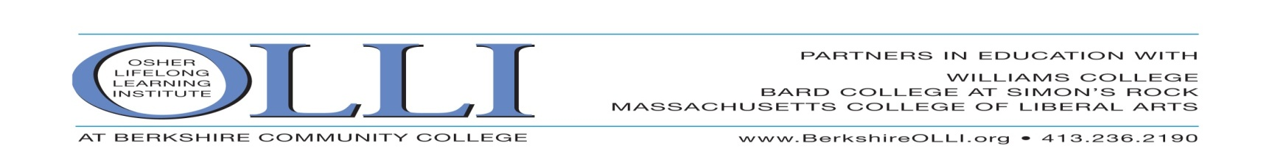
SPECIAL EVENTS COMMITTEE
Thursday - Sunday, NOV. 19 -22, 2020 online You select day!
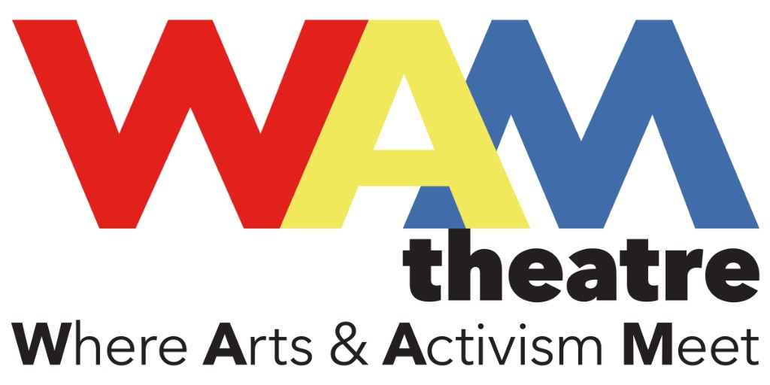

This Photo by Unknown Author is licensed under CC BY-NC

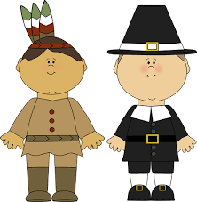
This Photo by Unknown Author is licensed under CC BY-ND
THE THANKSGIVING PLAY
By Larissa FastHorse (Sicangua Lakota Nation)
Directed by Talya Kingston

In this fast-paced satire good intentions collide with
absurd assumptions, as a troupe of white Liberal
teaching artists scramble to devise a grade school
theatre performance that somehow manages to celebrate turkey Day, while also honoring North American Heritage Month. WAM Theatre is honored to be connected with The Mohican Tribe (traditional stewards of the land on which we reside) who will be providing an introduction and cultural context to this production.

Post WAM theatre talk back: Nov. 24th 7PM www.wamtheatre.com.

Event Chair: Carol Sabot (413) 212.6588 Special Events Chair: Arline Breskin (413) 446.4102
Clip & Mail by November 15th to OLLI, BCC, 146 Bartlett Avenue, Pittsfield, MA 01201 or call 413.236.2190
WAM THEATRE “ THE THANKSGIVING PLAY” November 19-22

Name:_________________________________________Email:______________________________________

… ____ OLLI Member@$!3…………………………………………. $__________
____ Non-OLLI Member Guest @ $15 each………….…………..$__________
GRAND TOTAL $__________

Payment Options: Check Visa Master Card Discover Card American Express

Credit Card #: _________________________ Expiration Date (mm-yy)_________ Security code:_____
Print name as appears on card: ________________________________________________________
Billing Address of Card:_______________________________________________________________
Signature__________________________________________________________________________

